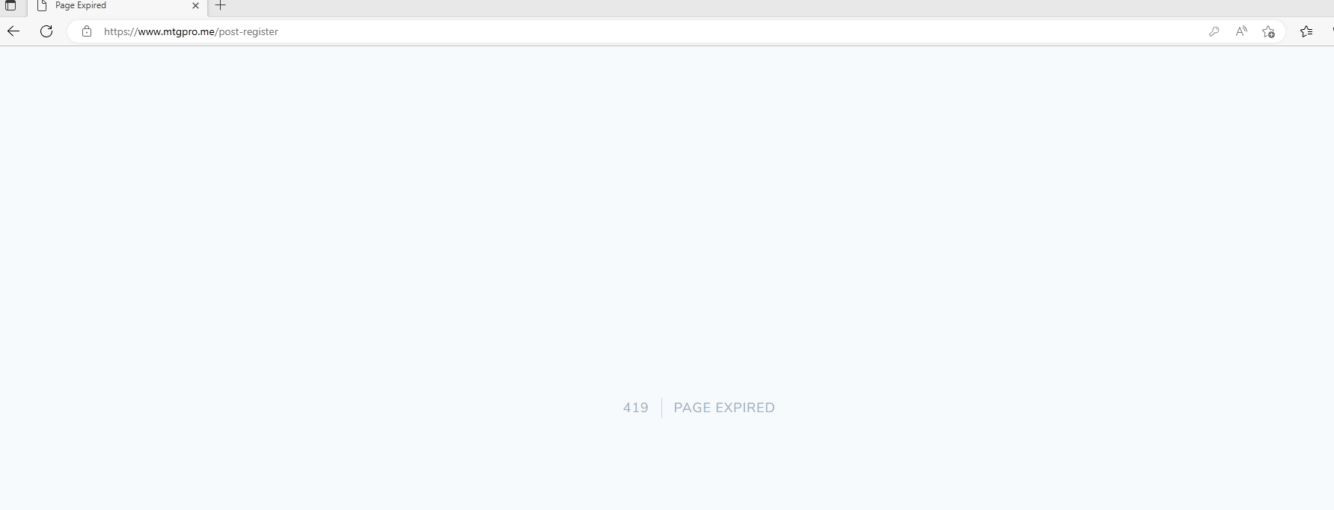

***Signup hoyna***

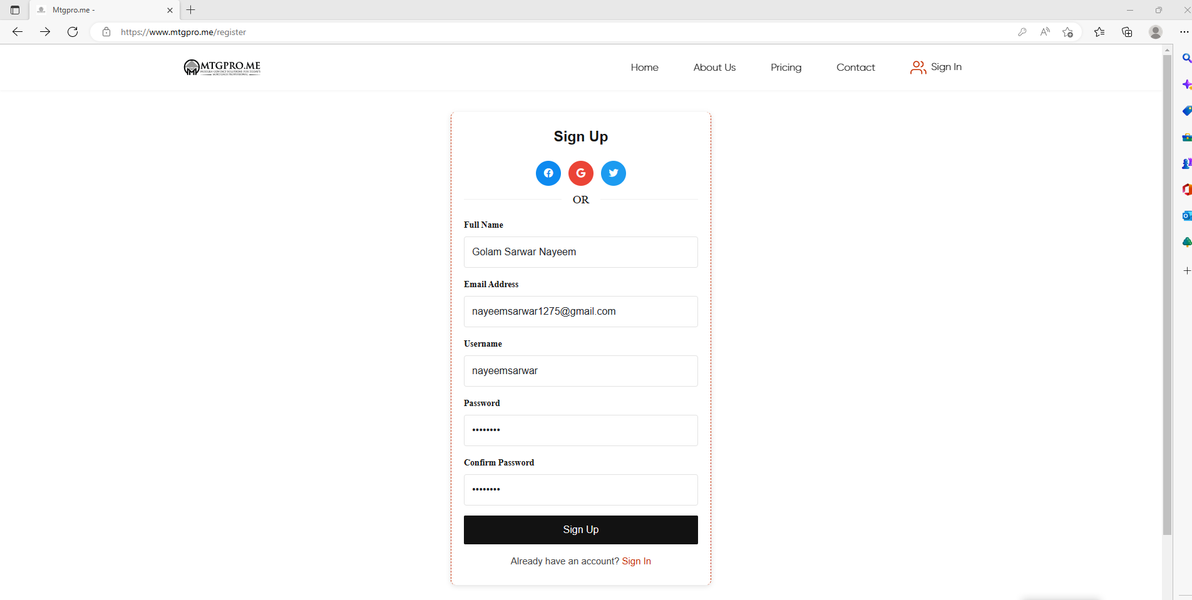

***Error dekhai***

***Card e edit hoyna***



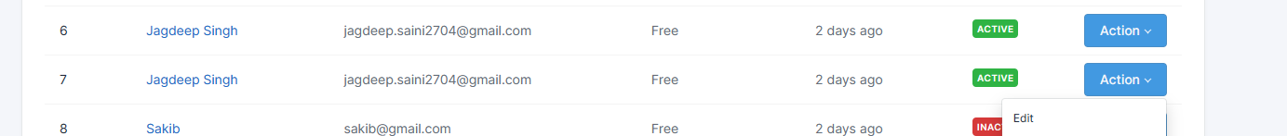

***Dashboard er overall income e click korle error dekhai***

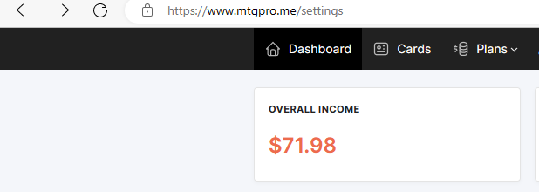

***error***

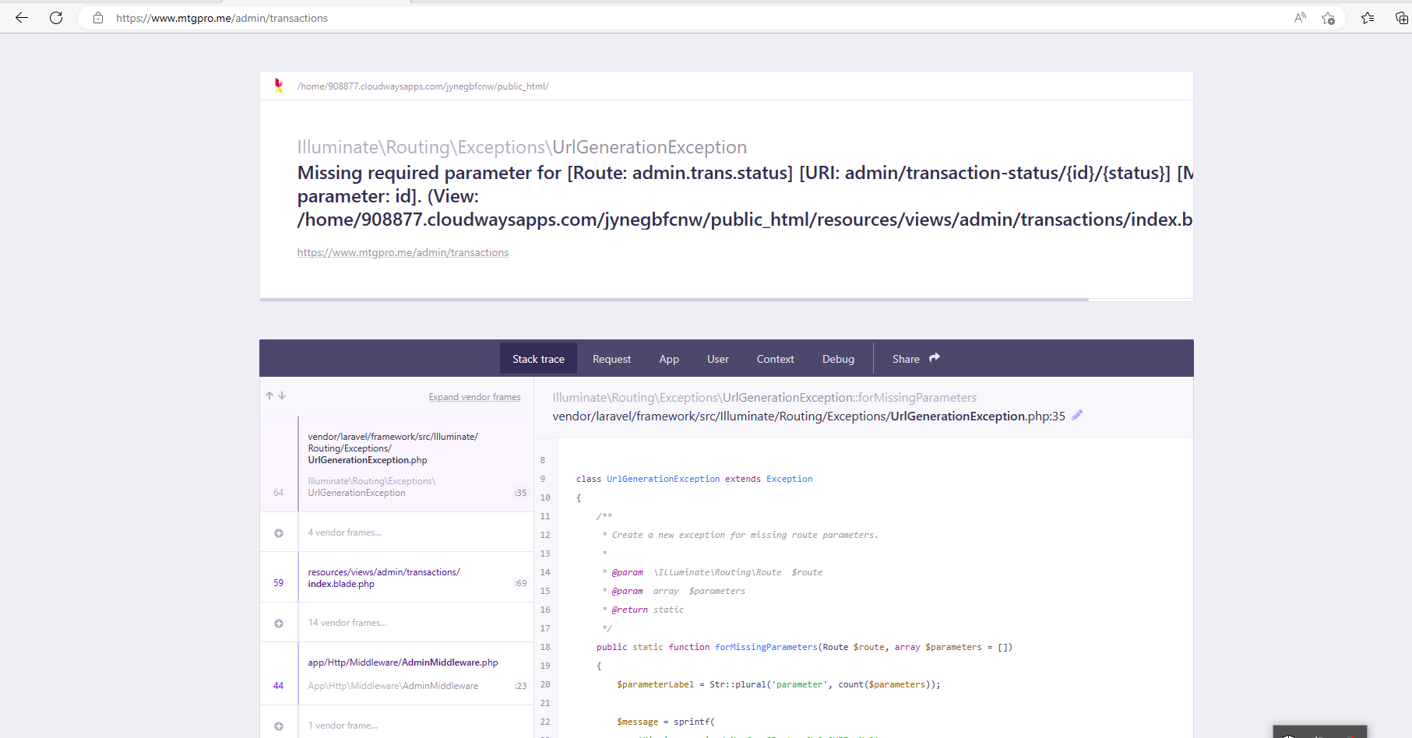

***Admin e Payment method e error dekache***

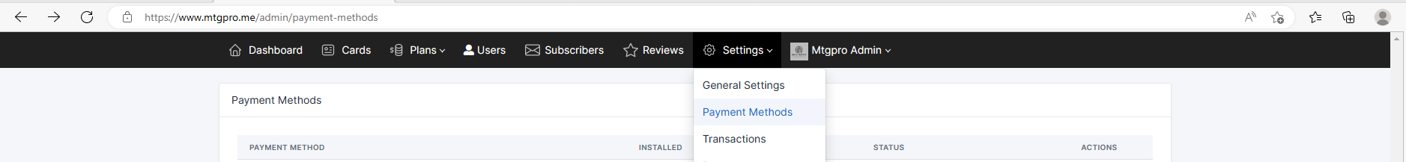

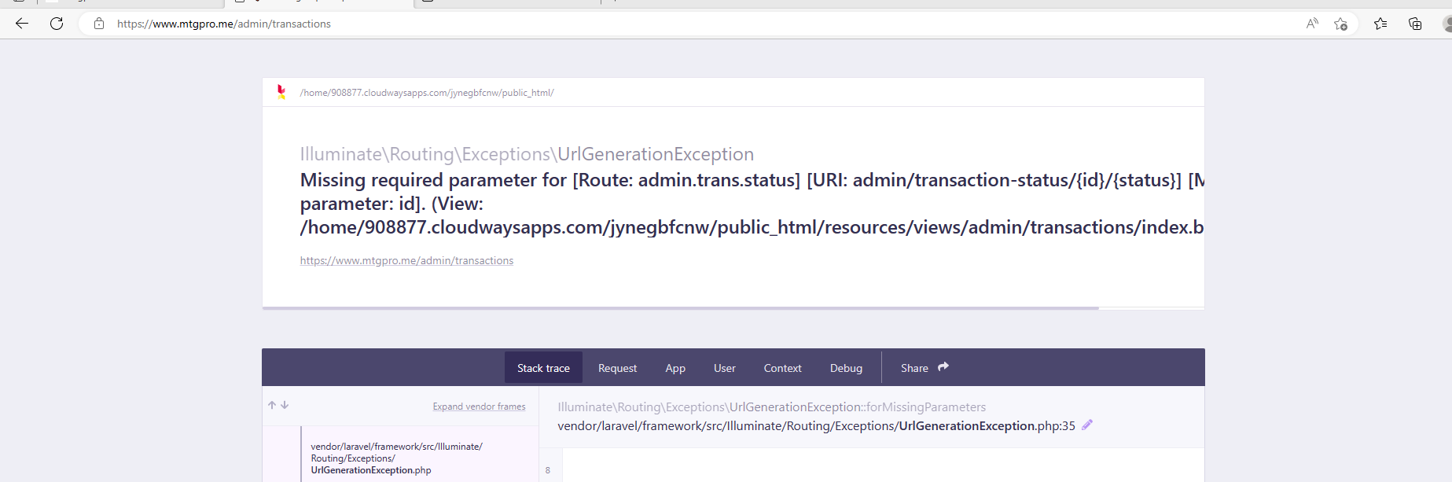

***Social icon instragram e kaj korsena linkedin e neya jai***



